[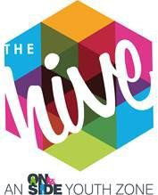](https://www.thehiveyouthzone.org/)COOKING TEACHER

**Location:** The Hive, Wirral Youth Zone

**Hours:** Evening & weekends

**Pay:** £10.42 per hour

**Reporting to:** Delivery Manager

# About Us

The Hive, Wirral Youth Zone, is a purpose-built facility for young people aged 8-19, or age 25 for anyone with a disability. Alongside providing young people with access to a range of activities under youth work provision, The Hive ensures young people have somewhere to go, something to do, and someone to talk to.

Wirral Youth Zone is centrally located and dedicated to raising aspirations and changing the lives of young people, giving them ‘Somewhere to go, something to do and someone to talk to’. Operating 5 days a week, at weekends and during school holidays, the Youth Zone’s purpose is to help young people grow to be happy, healthy, and successful adults. The state-of-the-art £6 million building provides young people with access to a range of activities, offering them the opportunity to try new things, meet new friends and gain support from friendly, warm, and positive staff and volunteers. The facilities include a 3G pitch, a gym, sports hall and recreation area, and dance, arts, music, and media suites.

# The Role

Cooking and food, is at the heart of The Hive’s offer to young people. We provide meals for £1 but we think it’s more important to teach our young people how to cook a healthy meal for themselves. You will be involved in teaching the fundamentals of cooking alongside hygiene awareness. This could be making cookies with the juniors or cooking a meal with the seniors, at the end of the day who doesn’t love FOOD.

Our Training Kitchen is part of a core offer that The Hive provides to young people. Our soon to be refurbished training kitchen is a space that is designed to equip young people with the skills and experience needed to learn how to cook healthy, nutritious and affordable meals as well as some special treats like cookies and cakes.

# Responsibilities

* To work directly with young people to plan, lead and deliver safe, fun and structured cooking sessions within Wirral Youth Zone, which are progressive and reflect the needs of young people.
* The role is 100% face to face delivery with young people
* To create a fun and engaging cooking offer that will inspire young people
* Get young people involved with themes, cultural celebrations and events that happen throughout the year and can be celebrated through food being prepared and made by young people
* To contribute to a training cooking programme that is high quality and meets the needs of the young people, including young people with additional needs and disabilities
* To support other programmes that contributes to the wider youth work agenda, supporting the development of young people
* To confidently manage and establish positive relationships with groups of young people
* To compile all monitoring information required to deliver impact statistics and encourage feedback from young people taking part in activities to share this with the team.
* To work with young people from a range of backgrounds and with a range of needs
* Effectively communicate at all levels, orally and in writing
* To work alongside other team members and provide guidance and support to young leaders and volunteers
* To attend regular training and development sessions and events where required
* To assist in identifying talented young people and encourage further development
* To maintain current knowledge of relevant cooking and hygiene policies and practices
* To promote cultural cohesion and inclusion and proactively challenge any prejudice and discrimination
* Any other duties as may reasonably be required

# Additional Information

The successful candidate will join a strong, supportive team often referred to as a family who all share the aspiration of giving young people the best opportunity to be the best version of themselves. The successful candidate will be given access to an employee assistance programme provided by Medicash, be eligible for the team recognition scheme and will be given the opportunity to attend multiple training sessions. Successful candidates will also have use of the onsite gym during restricted hours subject to a gym induction.

# Personal Specification

|  |  |  |
| --- | --- | --- |
| **Selection Criteria\***  A = Application Form I = Interview T = Test/Personality Profile | **Essential or Desirable** | **Method of Assessment** |
| **Experience** | | |
| Experience of leading cooking sessions and working with groups of young people aged 8-12 and/or aged 13-19 (up to  25 With Disabilities) | Essential | A & I |
| Experience of working with young people from diverse backgrounds and with challenging needs | Essential | A & I |
| Experience of working with young people with additional  needs and disabilities | Desirable | A & I |
| Experience of team working and alongside volunteers | Essential | A & I |
| **Qualifications** |  |  |
| Level 2 Food Hygiene or above | Essential | A |
| First aid qualification | Desirable | A |
| **Skills** |  |  |
| Ability to deliver high quality cooking/healthy eating sessions creatively with children and young people, including those who face social exclusion, disadvantage and disaffection and  manage such a group | Essential | A & I |
| Able to work as part of a team and under own initiative | Essential | A & I |
| Able to plan and evaluate programs of activity including production of session plans and evaluations | Essential | A & I |
| Able to communicate effectively with young people, parents, team members and members of the public.  Able to work under own initiative | Essential | A & I |
| Able to deliver within an equal opportunities’ framework | Essential | A & I |
| Ability to engage and build positive relationships with young people including disengaged and disadvantaged young  people | Essential | A & I |
| **Knowledge** |  |  |
| Understand the principles of working with children and young people, the issues affecting their lives and knowledge of their  needs | Desirable | A & I |
| Knowledge of health and safety, diversity awareness and safeguarding best practice | Essential | A & I |
| Basic knowledge of support pathways for young people | Desirable | A & I |

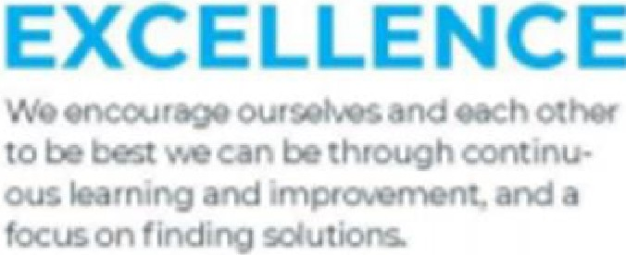



UT

AL



YO

K

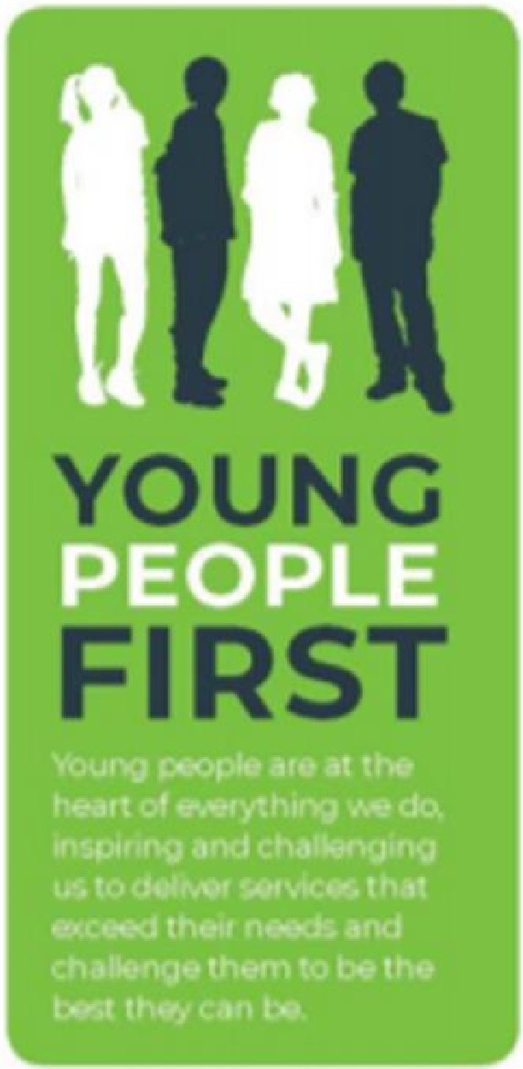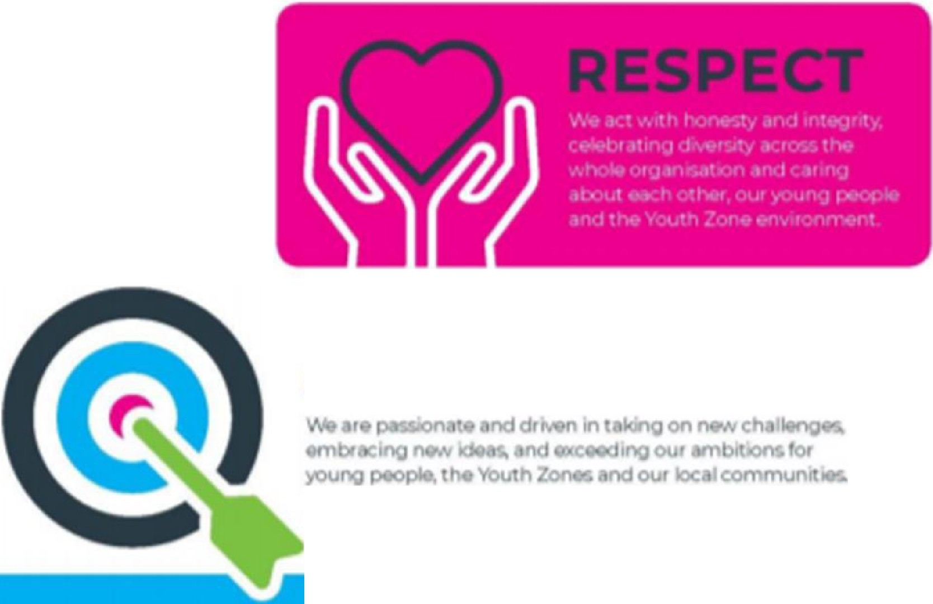

**A**

**OU**