[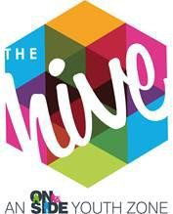](https://www.thehiveyouthzone.org/)BOXING COACH

**Location:** The Hive, Wirral Youth Zone

**Hours:** Will include Monday, Thursday & Sunday

**Pay:** £10.42 per hour

**Reporting to:** Sports Coordinator

# About Us

The Hive, Wirral Youth Zone, is a purpose-built facility for young people aged 8-19, or age 25 for anyone with a disability. Alongside providing young people with access to a range of activities under youth work provision, The Hive ensures young people have somewhere to go, something to do, and someone to talk to.

Wirral Youth Zone is centrally located and dedicated to raising aspirations and changing the lives of young people, giving them ‘Somewhere to go, something to do and someone to talk to’. Operating 5 days a week, at weekends and during school holidays, the Youth Zone’s purpose is to help young people grow to be happy, healthy, and successful adults. The state-of-the-art £6 million building provides young people with access to a range of activities, offering them the opportunity to try new things, meet new friends and gain support from friendly, warm, and positive staff and volunteers. The facilities include a 3G pitch, a gym, sports hall and recreation area, and dance, arts, music, and media suites.

# The Role

To help develop and deliver an exciting programme of boxing activities which will engage young people aged 8 – 19 years (up to 25 with disabilities) at Wirral Youth Zone. As a member of the team, you will have responsibility for engaging with young people and encourage them to engage in boxing activities and develop their skills and confidence through participation and engagement. You will be the lead coach for “Hive ABC” the Hives affiliated boxing clubs. Successful candidates will need to be available to work in the evenings and weekends, as well as supporting young people when they enter competitions.

# Responsibilities

* Together with the Sports Coordinator, develop and implement a boxing programme, ensuring we continue to develop and expand to meet the changing needs of our members.
* The role is 100% face to face delivery with young people.
* Carry out inductions for new users and then provide supervision in the boxing suite, promoting best practice and safe use for all young people.
* To plan, coordinate and deliver a comprehensive programmes and classes for young people, which will enable them to build their confidence, social skills, and overall wellbeing.
* Ensure the highest standards of health and safety are maintained in the boxing suite area.
* Ensure that all equipment necessary for each session is fit for purpose.
* Ensure equipment is stored correctly and securely after completion of each session.
* Carry out and log daily, weekly, and monthly checks, reporting any defects or faults to the Sports Coordinator. Carrying out remedial action where appropriate
* Assist with programme planning.
* Assist in the provision of risk assessments and report to the relevant Session Manager any accident or incident that requires attention, completing accident report forms as appropriate.
* Keep up to date on policies or procedures required for the safe operation of the gym and boxing suite.
* Ensure the areas are kept clean, tidy, and clear of rubbish at all times.

# Additional Information

The successful candidate will join a strong, supportive team often referred to as a family who all share the aspiration of giving young people the best opportunity to be the best version of themselves. The successful candidate will be given access to an employee assistance programme provided by Medicash, be eligible for the team recognition scheme and will be given the opportunity to attend multiple training sessions. Successful candidates will also have use of the onsite gym during restricted hours subject to a gym induction.

# Personal Specification

|  |  |  |
| --- | --- | --- |
| **Selection Criteria\***  A = Application Form I = Interview T = Test/Personality Profile | **Essential or Desirable** | **Method of Assessment** |
| **Experience** | | |
| Experience of leading boxing sessions and working with groups  of young people aged 8-12 and/or aged 13-19 (up to 25 With Disabilities) | Essential | A & I |
| Experience of working with young people from diverse backgrounds and with challenging needs | Essential | A & I |
| Experience of working with young people with additional needs and disabilities | Desirable | A & I |
| Experience of team working and alongside volunteers | Essential | A & I |
| **Qualifications** |  |  |
| Youth Work Qualification | Desirable | A |
| Relevant boxing qualification | Essential | A |
| **Skills** |  |  |
| Ability to deliver high quality boxing sessions creatively with children and young people, including those who face social  exclusion, disadvantage and disaffection and manage such a group | Essential | A & I |
| Able to work as part of a team and under own initiative | Essential | A & I |
| Able to plan and evaluate programs of activity including production of session plans and evaluations | Essential | A & I |
| Able to communicate effectively with young people, parents, team members and members of the public.  Able to work under own initiative | Essential | A & I |
| Able to deliver within an equal opportunities’ framework | Essential | A & I |
| Ability to engage and build positive relationships with young  people including disengaged and disadvantaged young people | Essential | A & I |
| **Knowledge** |  |  |
| Understand the principles of working with children and young  people, the issues affecting their lives and knowledge of their needs | Desirable | A & I |
| Knowledge of health and safety, diversity awareness and safeguarding best practice | Essential | A & I |
| Basic knowledge of support pathways for young people | Desirable | A & I |

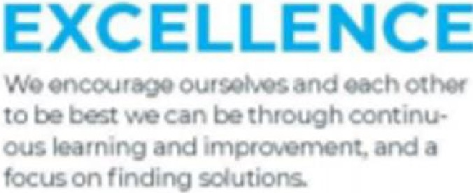



UT

AL



YO

K

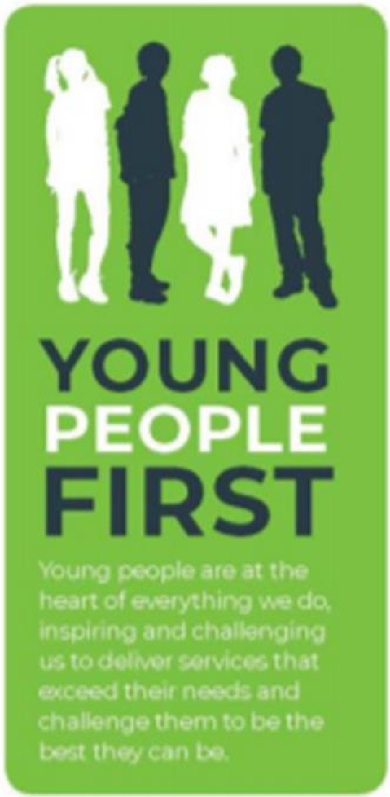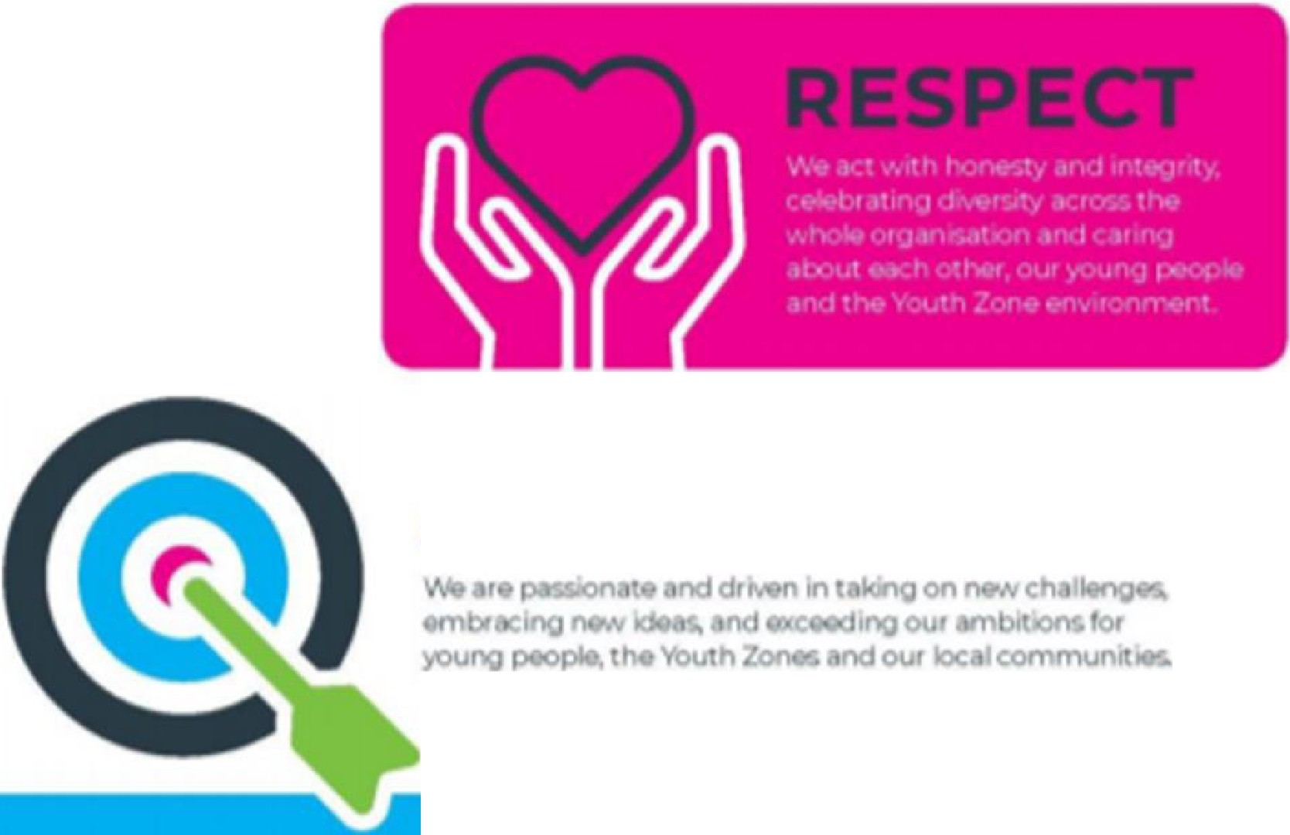

**A**

**OU**